**List of Assignments (Jul-Dec 2022)**

**Lab Name:**Skill based Lab Course: Object Oriented Programming with Java

**Lab Code :** CSL304

**Class :**SE (Computer Engineering ) **Sem :** III

1. **Program on accepting input through keyboard.**
   1. WAP to print the Percentage range of a student as per following criteria for the grade accepted via Scanner Class

Percentage Grade

0-60 F

61-70 D

71-80 C

* 1. B
  2. A
  3. Admission to a Professional Course is based on following conditions :
     1. Marks in mathematics >=60
     2. Marks in Physics >=50
     3. Marks in Chemistry >=40
     4. Total marks in three subjects >=200

Accept the marks in three subjects( use BufferedReader class) and decide if the student is eligible to get admission or no

1. **Programs on Basic programming constructs like branching and looping**
   1. WAP to print a two dimensional table of squares of numbers from 1 to 25 using for loop
   2. WAP to find number of and sum of all integers greater than 100 and less than 200 that are divisible by 7
2. **Programs based on Command-line arguments**
   1. WAP to accept student’s details via command line and display on the screen
   2. WAP to calculate minimum and maximum of three numbers accepted via Command line.
3. **Programs on Classes and objects**
   1. WAP to read and display details of an employee using single class and its object
   2. WAP to find maximum of three numbers using conditional operator, using two classes and function returning result
4. **Programs on One Dimensional Arrays** 
   1. WAP to count number of even and odd elements from an array
   2. WAP to count total marks and highest marks obtained by a student.
5. **Programs on Two Dimensional Arrays** 
   1. WAP to find Transpose of a Matrix (One class ,only main)
   2. WAP to Pass a 2D Matrix to a function which determines if it is a square matrix. If not, program should come to end else the program should find sum of all diagonal elements of a Matrix.
6. **Programs on Array of Objects**

a. 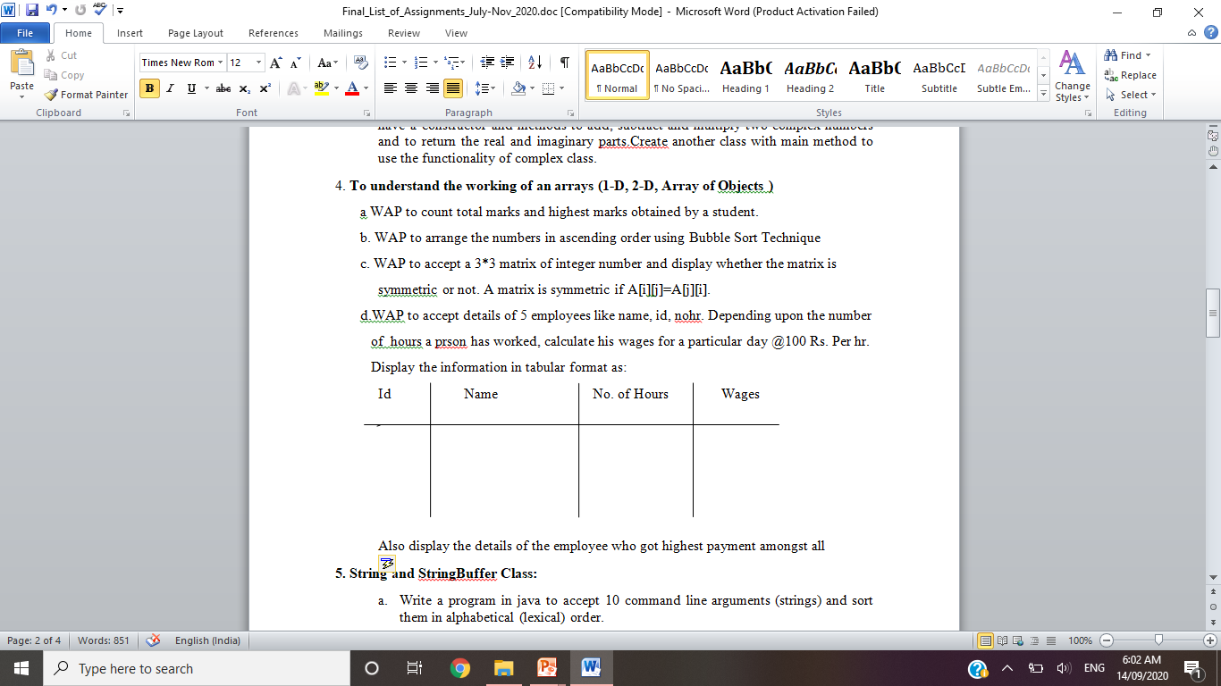For Annual Examination results of 5 students, taking into consideration marks obtained in three subjects, WAP to determine

* 1. Determine Total marks obtained by each student
  2. The student who obtained highest total marks

1. **Program on Strings**
   1. WAP to check if a string is a palindrome
   2. WAP to accept a string from user and display the number of uppercase, lowercase, special characters, blank spaces & digits present in the accepted string.
2. **Program on Method and Constructor overloading.**
   1. Calculate area of different shapes ( Square, Rectangle , Circle) using method overloading and multiple class concept.
   2. Calculate area of different shapes ( Square, Rectangle , Circle) using constructor overloading and multiple class concept.
3. **Program on Exception Handling**
   1. WAP to catch any three built-in exceptions
4. **Program on User Defined Exception**
   1. WAP to accept any integer from the user & if the entered number is not any of 5 or 6 or 7 then create an exception & catch it
   2. WAP to create an exception ‘PayOutOfBounds’ when the basic pay paid to the Superintendent it is less than 25,000 and greater than 50,000.
5. **Program on Multithreading**
   1. WAP to create two threads and fetch the names of the thread.
   2. WAP that has two threads. One of the threads should print odd numbers from 1 to 15 while the other displays even number.
6. **Program on Packages**

Write a program to perform four basic Arithmetic Operations using packages

Each operation should be a part of each class inside the package

Main class should import all the packages and perform operations .

1. **Program on Inheritance**

Write a Java program to implement following Inheritance



1. **Program to create a GUI based Application**

Create a registration form containing required fields .

The form should have all the studied components

The form should have minimum two buttons “Submit” and “Cancel”….giving appropriate messages at corresponding click

1. **Written Assignment #01**

Write Short Notes on

1. Features of Java
2. JVM, JDK & JRE
3. Wrapper Classes
4. Life cycle of a Thread
5. **Written Assignment #02**

Write Short Notes on

1. Thread synchronization
2. Abstract classes
3. JDBC Drivers and Architecture
4. Life cycle of an applet

**Subject In-charge**

**Juhi Janjua**